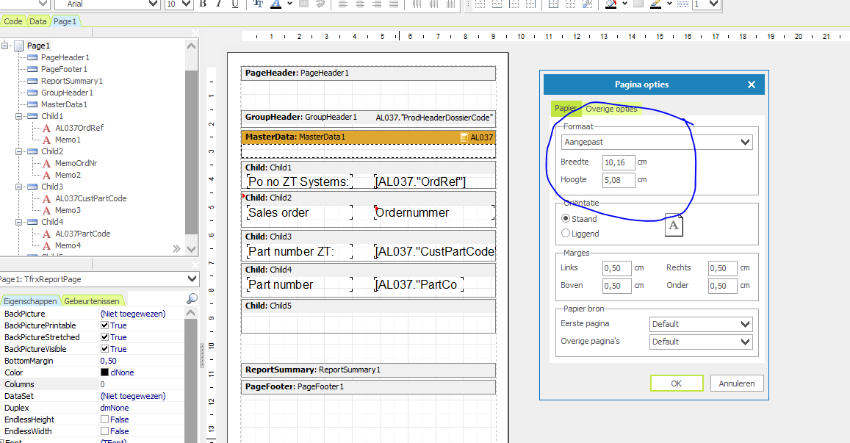

Page properties 1 label

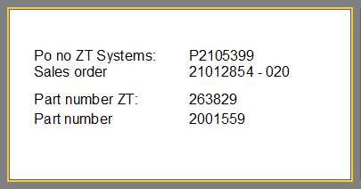

This needs to be repeated 2 colums, 6 rows.

What should I set?
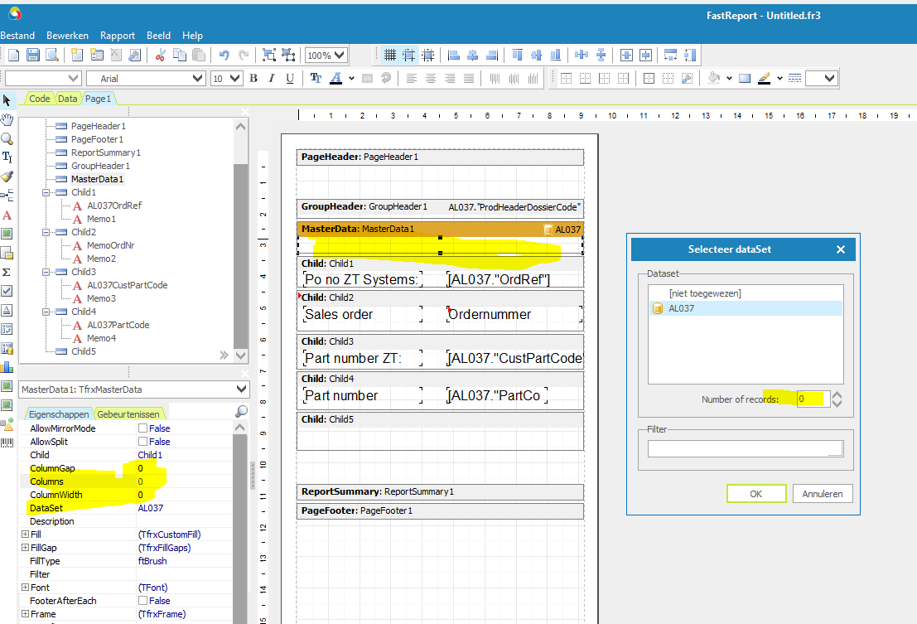

Setting Colums to 2 and Columwidth to 10 does not seem to work.

?

